

European Urban Knowledge Network

EUKN Spelling and Style Guide

Date: | 11 January 2007
Version: | Final
 | This publication is the responsibility of:
 | EUKN Secretariat
Address: | Laan van N.O. Indië 300, NL-2593 CE The Hague, Netherlands  PO Box 90750, NL-2509 LT The Hague, Netherlands
Phone: | +31 70 3440745
E-mail: | secretariat@eukn.org
Internet: | www.eukn.org
Content

Foreword page 2

Part 1 - EUKN Spelling Guide page 3

1.1 General guidelines page 3
1.2 General terms page 3
1.3 EUKN policy areas page 3
1.4 Website-related terms page 3
1.5 Country abbreviations page 4
1.6 Language abbreviations page 4
1.7 Figures page 4
1.8 Percentages page 4
1.9 Dates page 4
1.10 Telephone and fax numbers page 5

Part 2 – EUKN Style Guide page 6

2.1 Filling out EUKN templates page 6
2.2 Research, policy and practice templates page 6
2.2.1 Meta information / meta data page 6
2.2.2 Header and title page 6
2.2.3 Contact data page 7
2.3 Meeting template page 7
2.4 News template page 8
2.5 Uploading templates in Hippo page 8
2.5.1 Links to external websites page 8
2.5.2 Files page 9
2.5.3 Extra headings page 9
2.5.4 Use of bullets page 10

Annex - Overview of field names in EUKN templates and page 12
Hippo templates

Foreword

One of the outcomes of the discussions during the National Focal Point Day in Brussels was that EUKN and its e-library should focus on quality rather than quantity. The EUKN spelling and style guide will help ensure the uniformity and the quality of the knowledge provided in the EUKN e-library. The guide has specifically been developed for those involved in uploading knowledge documents at the National Focal Points and the EUKN Secretariat.

As the title of this document indicates, it consists of two parts. The first part is the spelling manual for the central EUKN website and the websites of the National Focal Points. The second part focuses on the style and lay-out of the EUKN websites.

If you have a question to which this spelling and style guide does not provide a satisfactory answer, please contact the EUKN Secretariat.

The Hague, 11 January 2007
PART 1 - EUKN SPELLING GUIDE

1.1 General guidelines
- Always use BRITISH spelling, compare for example programme (UK) and program (US).
- Please use the Word spelling checker on all filled-out templates to prevent spelling errors, compare for example accomodation (incorrect) and accommodation (correct).
- Preferably, all templates are checked by a native speaker of English.

Please use the following spelling for the below-listed terms:

1.2 General terms
- European Urban Knowledge Network (EUKN). If used in full, European Urban Knowledge Network is preceded by ‘the’. The abbreviation EUKN is used as a name, without a preceding ‘the’.
Examples: The meeting was hosted by the European Urban Knowledge Network.
EUKN has launched a call for thematic studies.
- (the) URBACT Programme
- EUROCITIES
- European Commission (EC)
- European Parliament (EP)
- Directorate-General (DG/DGs)
- Science and Research Directorate-General (DG Research)
- Competition Directorate-General (DG Competition)
- Justice, Freedom and Security Directorate-General (DG Justice)
- Regional Policy Directorate-General (DG Regio)
- EUKN Secretariat
- Steering group (SG)
- Knowledge manager (KM/KMs)
- IT experts
- EU Member State (MS/MSs)
- National Focal Point (NFP/NFPs)
- NFP Day
- Nicis Institute
- Ministry
- Minister

1.3 EUKN policy areas
- Urban environment
- Housing
- Transport and infrastructure
- Economy: knowledge and employment
- Social inclusion and integration
- Security and crime prevention

1.4 Website-related terms
- www.eukn.org
- EUKN search portal
- research desk
- virtual files
- e-library
- on-line database
- EUKN Research & Practice Review
- NFP website
1.5 Country abbreviations
- Belgium – BE
- Cyprus – CY
- Germany – DE
- Denmark – DK
- Spain – ES
- Finland – FI
- France – FR
- United Kingdom – UK
- Greece – GR
- Hungary – HU
- Italy – IT
- Luxembourg – LU
- Netherlands – NL
- Poland – PL
- Portugal – PT

1.6 Language abbreviations
- Danish - Dan
- Dutch - Dut
- English - Eng
- Finnish - Fin
- French - Fre
- German - Ger
- Greek - Gre
- Hungarian - Hun
- Italian - Ita
- Portuguese - Por
- Spanish - Spa

1.7 Figures
- Figures 1 to 20: write out in words
Example: Eleven children were playing in the park.
- Figures smaller than 1 million: write out in digits, with commas to distinguish between thousands, ten thousands and one hundred thousands.
Examples: 8,000 ( = eight thousand) / 80,000 ( = eighty thousand) / 800,000 (= eight hundred thousand)
- Figures larger than 1 million: digit + million / billion and round off to one decimal.
Examples: 8 million / 1.5 million / 6 billion
- Financial figures: always write out in digits + name of currency.
Examples: 2 euros / 11,85 euros / 1,500 euros / 800,000 euros / 1 million euros / 8.5 million euros

1.8 Percentages
- Use the word per cent, not the percentage symbol (%).
- Round off to one decimal.
Examples: 1.5 per cent / 50 per cent

1.9 Dates
- Lay-out dates: number of day + name of month + year.
- Days of the week: Sunday, Monday, Tuesday, Wednesday, Thursday, Friday, Saturday
Example: Monday, 17 December 2006
- When referring to past decades: write out the year in digits + s.
Examples: 1950s ( = the fifties) / 1980s ( = the eighties)
- When referring to centuries: number of century + nd / th / st.
Example: 2nd century / 17th century / 21st century

1.10 Telephone and fax numbers
- Always provide a country code.
- Lay-out: Use a “+” in front of the country code, followed by the direct phone/fax number.
Example: +44 1224 237685

PART 2 - EUKN STYLE GUIDE

2.1 FILLING OUT EUKN TEMPLATES
- Please fill out the templates as comprehensively as possible!
- Sentences of max. 25 words.
- Paragraphs of max. 5 lines (in the preview of the webpage).
- One white line between each paragraph.
- Use of abbreviations: when used for the first time in the text, please write out the phrase in full
with the abbreviation in brackets behind it.
Example: Urban poverty is a problem in the European Union (EU). The EU has therefore joined forces with the World Bank to combat poverty in cities.

2.2 RESEARCH, POLICY AND PRACTICE TEMPLATES

2.2.1. Meta information / meta data
    - Meta information should be entered as accurately as possible. This is important for the structure of the EUKN websites. Please refer to figure 2.1 for more information on how to fill out the meta information fields.

Figure 2.1
Meta information
Language | English
Contributing country | Please select the name of your country.
Editor | Please fill out the first and surname of the person that is uploading the documents.
Covering city | Please select the city or cities to which the research / policy / practice applies. If a city is missing from the list please contact the Secretariat and it will be added for you. Please use the English name of cities, if available.
Keywords | Please select one or more of the keywords from the list given in Hippo which corresponds to the keywords list in the EUKN taxonomy (if applicable). It is not possible to add other keywords to the list.
Institutional characteristics of the author / research institution | Please select the type of author or research institution from the list.
Publication date (policy documents) | Please enter the publication date.
Start date / End date (research documents) | Please enter the publication date in the ‘start date’ field, leave the ‘end date’ field blank.
Project start date / Project end date (practice documents) | Please enter the start and end date of the practice.
Rating | Rating is always 1 because the documents are not validated yet.

2.2.2 Header and title
- Header and title should be the same!
- Header and title: short and simple but as informative as possible.
- Lay-out of header and title: header/title – city, country abbreviation, see figure 2.2.

Figure 2.2
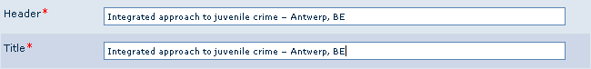

2.2.3 Contact data
- It is not necessary to fill out all the fields in the ‘contact data’ section. Organisation name + phone number or e-mail address will suffice.
- If you have a contact person, you can fill out his/her name, function and phone number or e-mail address in the ‘person’ fields. If this is this case, you do not have to give the general phone number or e-mail address of the organisation, see figure 2.3.
- The link to the website of the organisation should be provided in the ‘links’ section, not in the URL organisation field.

Figure 2.3
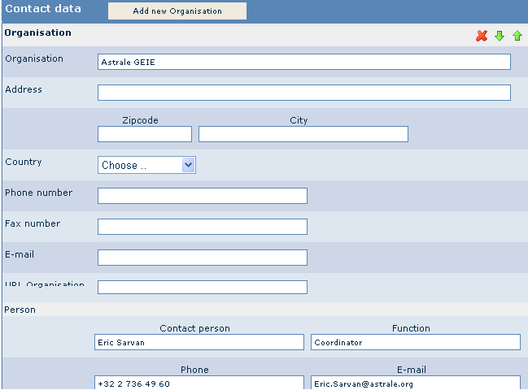

2.3. MEETING TEMPLATE
- Header and title should be the same!
- Lay-out header and title: title conference - city, date (see figure 2.4).
- Lay-out location: city, country (see figure 2.5).
- Text ‘links’ section: describe to which website the user is redirected.
Example: For more information and to register, please visit the conference website

Figure 2.4
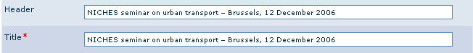
Figure 2.5
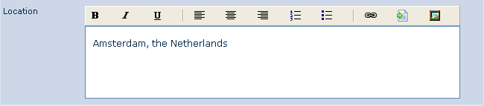

2.4 NEWS TEMPLATE
- Header and title should be the same!
- Header and title: short and catchy, but always informative, see figure 2.6.
- Use the ‘source’ section to insert link to the source of the news item. Additional links can be inserted in the ‘links’ section.

Figure 2.6
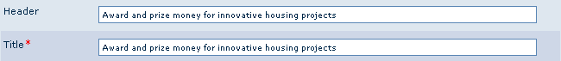

2.5 UPLOADING TEMPLATES IN HIPPO
- After publishing a document in Hippo, always check the preview of the webpage for spelling and style errors. To see latest changes, press ctrl-F5.
- Some names of fields in the EUKN templates differ from the names that the fields have in Hippo, please refer to the annex for more information.

2.5.1 Links to external websites
- Links to all relevant websites should be provided in the ‘links’ section. Please do not add hyperlinks in plain text, as shown in figure 2.7.

Figure 2.7
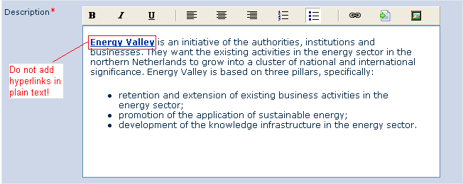

- External websites should be opened in a blank window. Please select ‘blank window’ in the target window field.
- The text added in the text field needs to be as informative as possible so that, when clinking the link, the website users know where they are being directed to.
- If a website is not available in English please add this to the text in the text field.
Example: Ministry of Trade and Industry (in Danish)

2.5.2 Files
- When possible, upload PDF/Word file in Hippo in the ‘files’ section, see figure 2.8. Do not provide a web link to external PDF/Word file.

Figure 2.8
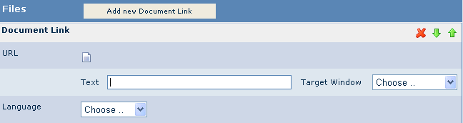

- Lay-out text field of the ‘files’ section: please enter the complete title of the described document in English followed in brackets by
  - document format (Word/PDF)
  - abbreviation of the language in which the document is written (see section 1.6 of the spelling guide)
  - size of the document in KB or MB
Examples: Evaluating urban regeneration in Spanish cities. Final Report (PDF, Spa, 450 KB)
LIFE in the City - Innovative solutions for Europe’s urban environment (PDF, Eng, 4.2 MB)
- Files should be opened in a ‘blank window’. Please select ‘blank window’ in the target window field.

2.5.3 Extra headings
- Please avoid using other headings than the ones provided in Hippo. If extra headings are required, please make them bold, as shown in figure 2.9.

Figure 2.9
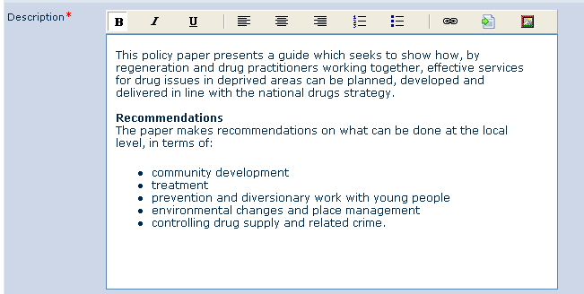

2.5.4 Use of Bullets
- Use Hippo bullets when listing: compare figure 2.10 (correct) with figure 2.11 (incorrect).

Figure 2.10 Hippo bullets - correct
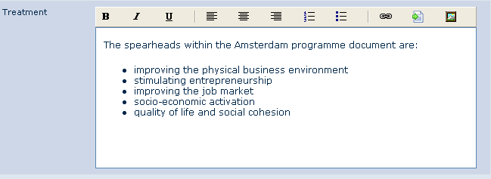

Figure 2.11 Word bullets - incorrect
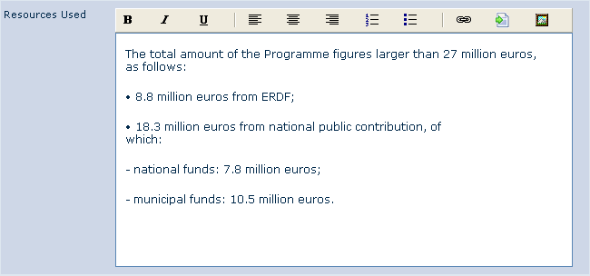

- All bulleted and numbered lists are preceded by an introductory sentence, which ends with a colon, see figure 2.10.
    - If you are listing short phrases do not use punctuation marks in the list, also see figure 2.10.

- Use semicolons to separate each item of the list when these are sentences, last phrase is followed by a full stop, see figure 2.12.

Figure 2.12
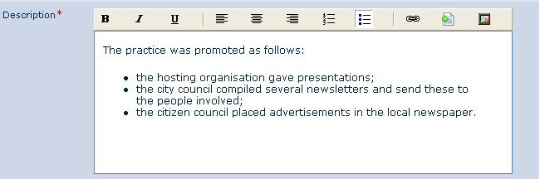

ANNEX - OVERVIEW OF FIELD NAMES IN EUKN TEMPLATES AND HIPPO TEMPLATES

I. Research documents
Name field in EUKN template | Name field in Hippo template
Title | Content > Title + header
Contributing country | Meta information > Contributing country
Covering city | Meta information > Covering city
Publication date | Meta information > Start date
Rating | Meta information > Rating
Main placement | -
Keywords | Meta information > Keywords
Introduction | Content > Introduction
Summary | Content > Summary
Background information | Content > Background information
Methodology | Content > Methodology
Conclusions | Content > Conclusions
Researcher | Content > Researcher
EU involvement | Content > EU involvement
ISBN | Content > ISBN
ISSN | Content > ISSN
Organisation | Content > Contact data > Organisation
Contact person | Content > Contact data > Contact person
Function | Content > Contact data > Function
Phone | Content > Contact data > (Person) > Phone
E-mail | Content > Contact data > (Person) > E-mail
Links (URL) | Content > Link > URL
Links (Text) | Content > Link > Text

II. Policies
Name field in EUKN template | Name field in Hippo template
Title | Content > Title + header
Publication date | Meta information > Publication date
Contributing country | Meta information > Contributing country
Covering city | Meta information > Covering city
Main placement | -
Keywords | Meta information > Keywords
Introduction | Content > Lead
Summary | Content > Description
EU involvement | Content > EU involvement
Creator | Content > Author or Organisation (depending on whether the policy was written by a person or an organisation)
Organisation | Content > Contact data > Organisation
Contact person | Content > Contact data > Contact person
Function | Content > Contact data > Function
Phone | Content > Contact data > (Person) > Phone
E-mail | Content > Contact data > (Person) > E-mail
Links (URL) | Content > Links > URL
Links (Text) | Content > Links > Text

III. Practices
Name field in EUKN template | Name field in Hippo template
Title | Content > Title + header
Project start date | Meta information > Project start date
Project end date | Meta information > Project end date
Contributing country | Meta information > Contributing country
Covering city | Meta information > Covering city
Rating | Meta information > Rating
Main placement | -
Keywords | Meta information > Keywords
Introduction | Content > Introduction
Summary | Content > Summary
Issue | Content > Problem
Approach | Content > Treatment
Results | Content > Results
Resources used | Content > Resources used
Beneficiaries | Content > Beneficiaries
EU involvement | Content > EU involvement
Organisation | Content > Contact data > Organisation
Contact person | Content > Contact data > Contact person
Function | Content > Contact data > Function
Phone | Content > Contact data > (Person) > Phone
E-mail | Content > Contact data > (Person) > E-mail
Links (URL) | Content > Links > URL
Links (Text) | Content > Links > Text

IV. Networks
Name field in EUKN template | Name field in Hippo template
Network title | Content > title + header
Network start date | Meta information > Project start date
Network end date | Meta information > Project end date
Contributing country | Meta information > Contributing country
Covering city | Meta information > Covering city
Main placement | -
Keywords | Meta information > Keywords
Introduction | Content > Lead
Summary | Content > Description
Participants | Content > Participants
Network lead | Content > Network lead
Objectives | Content > Objectives
Products | Content > Products
EU involvement | Content > EU involvement
Organisation | Content > Contact data > Organisation
Contact person | Content > Contact data > Person > Contact person
Function | Content > Contact data > Person > Function
Phone | Content > Contact data > (Person) > Phone
E-mail | Content > Contact data > (Person) > E-mail
Links (URL) | Content > Links > URL
Links (Text) | Content > Links > Text

